# Homework #6: User Management

|  |
| --- |
| * This is an individual assignment, and is worth 20 points. * The due date is Tuesday, March 17th. * The database for the assignment - AdventureWorks2016CTP3 – in installed on our Proxmox server. You should download this document after you login to the Proxmox server. * You should answer the questions in blue. * You will get deductions if the requested screenshots are not provided. * Please zoom in your output. I will penalize you if you do not zoom in. |

# Task #4. Assigning User Mappings to Fixed Database Roles

## A. Assigning a user to a database role

## B. Verifying the results

5) Does it fail? Show the result in a screenshot. Describe your observation and explain why it fails.

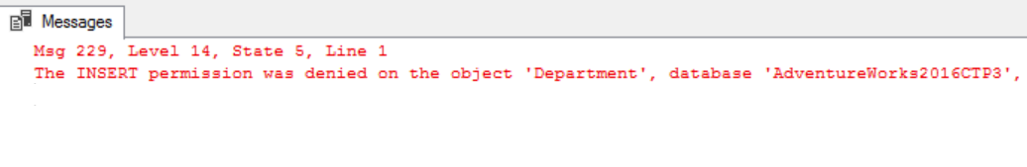

The insert fails because TestUser-A was denied write permissions.

10) Does it fail? Show the result in a screenshot. Describe your observation and explain why it fails.

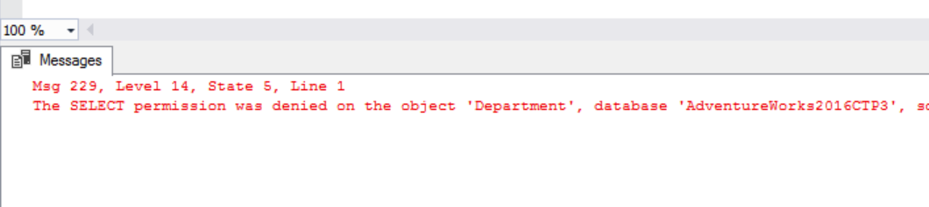

The select failed because TestUser-B was denied read permissions.

# Task #5. Creating a Custom Database Role

## A. Creating a custom database role

## B. Verifying results

4) Does it work? Show the result in a screenshot. Describe your observation and explain why it works.

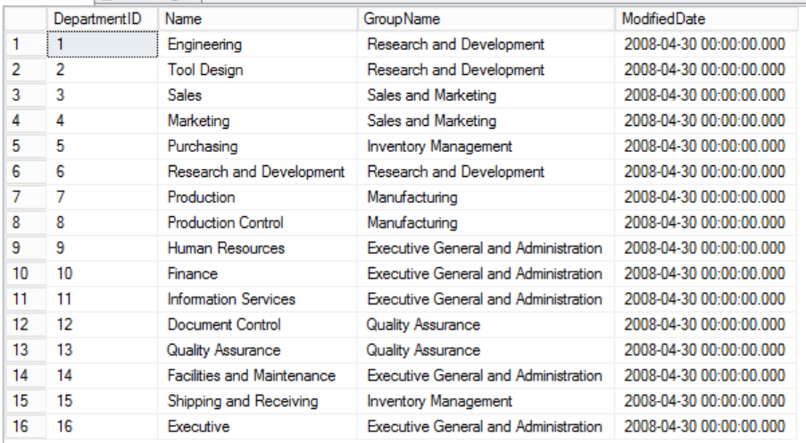

The select works because the user role gave permission to TestUser-C to perform select queries

5) Does it fail? Show the result in a screenshot. Describe your observation and explain why it fails.

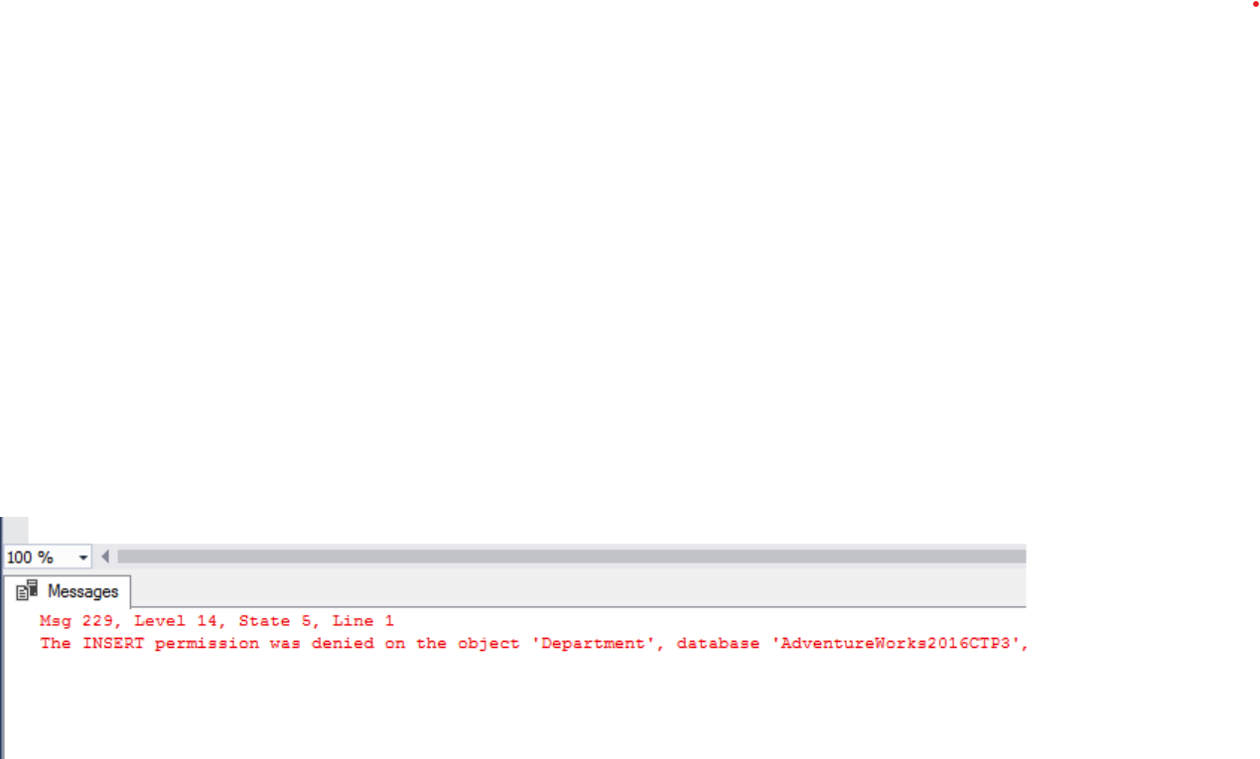

The insert fails because TestUser-C belongs to a user role that only has SELECT permissions.

# Task #6. Creating an Application Role

## A. Creating an Application Role

## B. Verifying Results

2) Does it fail? Show the result in a screenshot. Describe your observation and explain why it fails.

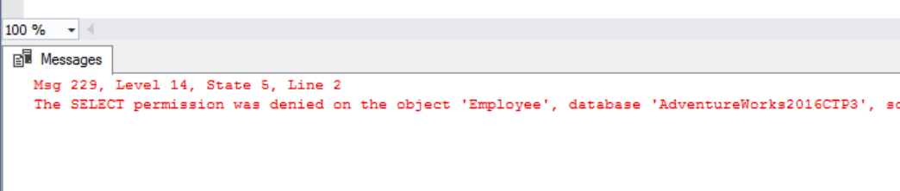

The select was denied because TestUser-B does not have a preset app role.

4) Does it work? Show the result in a screenshot. You have to click on Results to view the results. Describe your observation and explain why it works.

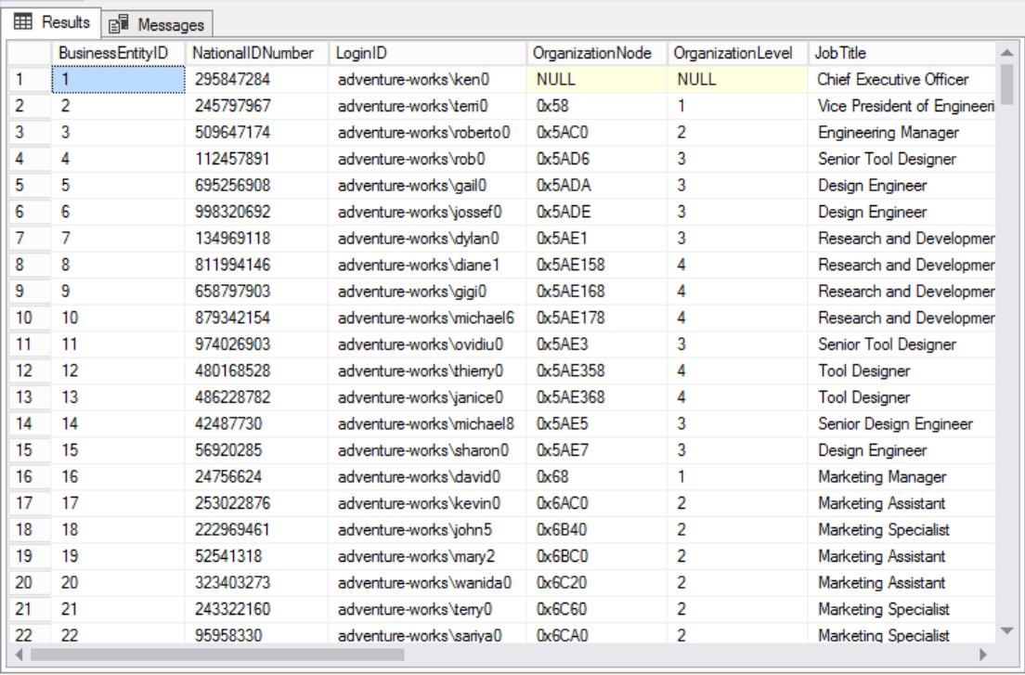

Because TestUser-B has not been given a role, the query runs as expected.

# Task #7. Assigning Permissions

9) Does it work? Show the result in a screenshot. Describe your observation and explain why it works.

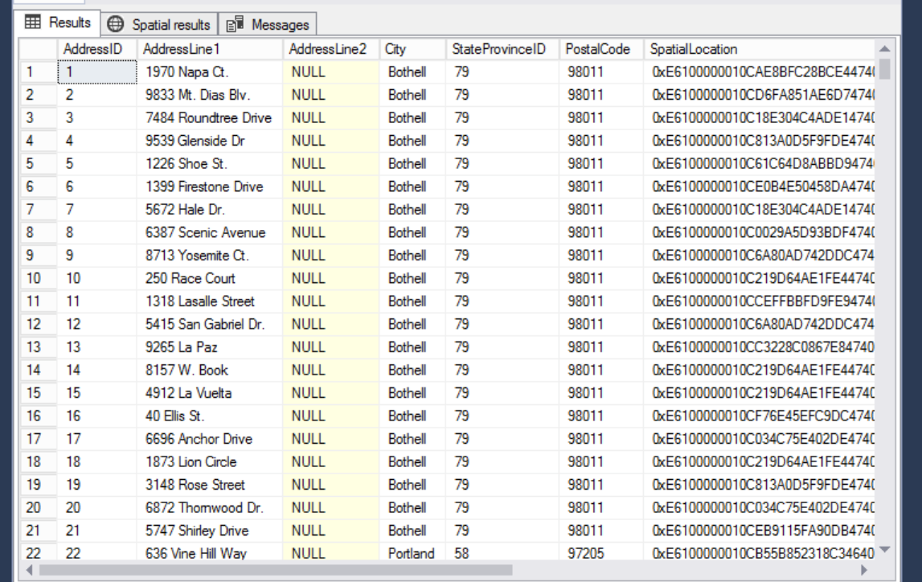

The query works because TestUser-A was given permission to perform select queries on the Address table.

13) Run the previous query. Show the result in a screenshot. Describe your observation and explain why it fails.

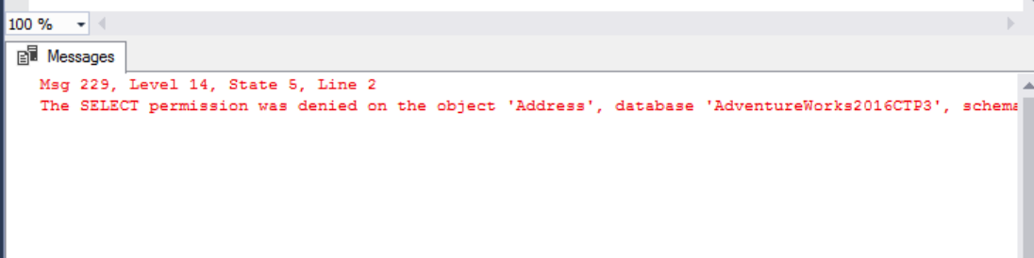

The select fails because we have now revoked permission from TestUser-A to perform select statements

15) Run the previous query. Show the result in a screenshot. Describe your observation and explain why it works.

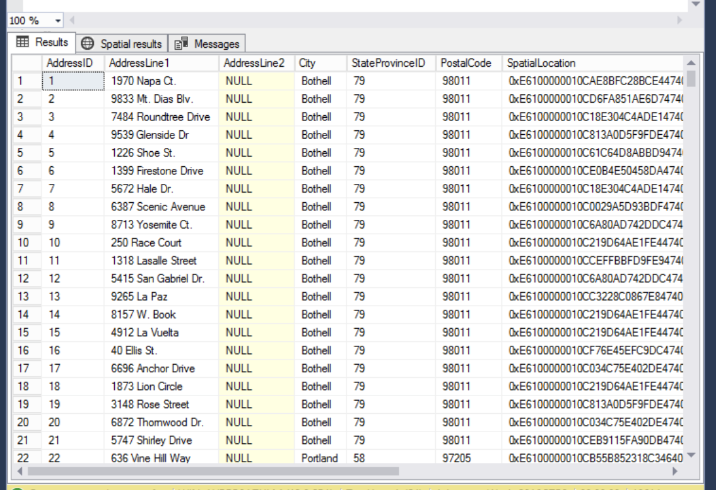

The query now succeeds because the db_datareader role surpasses the lack of permission.

19) Run the previous query. Show the result in a screenshot. Describe your observation and explain why it fails.

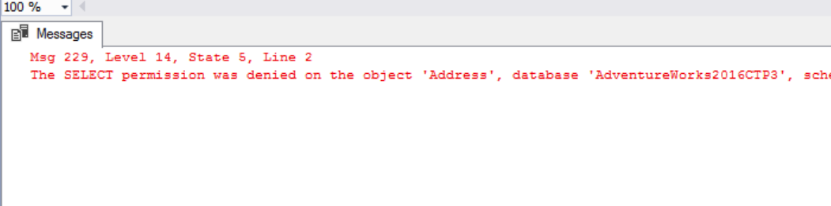

The query now fails because a denied permission has higher power than a role or a missing permission.